The ‘Sony Entertainment Sampler’

The aims of my project were to create an easy to use, musical sounding sampler which operated through the use of a game controller. The idea of a controller being used in the composition has been around since the 1981 with the implementation of MIDI in keyboard controllers.

I decided that I wanted to use something less intrinsically musical to control the samples, an idea that Don Buchla and Morton Subotnik had when they were building their modular synthesizers such as the 200e.

I chose the Sony PS4 controller, because it has 18 assignable buttons and two 360° toggles. Using the [HID] object, I was able to map all of these button outputs to samples.

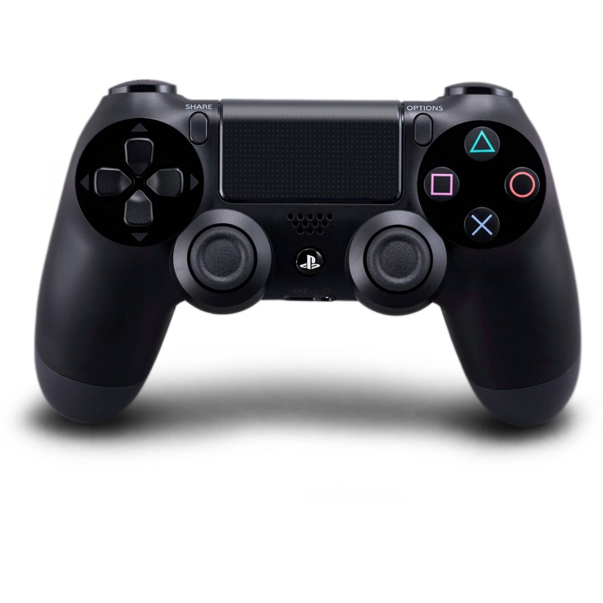
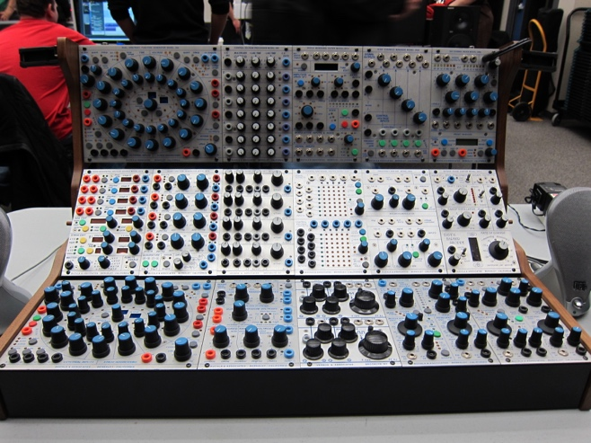
Sony PS4 Controller
Buchla 200e

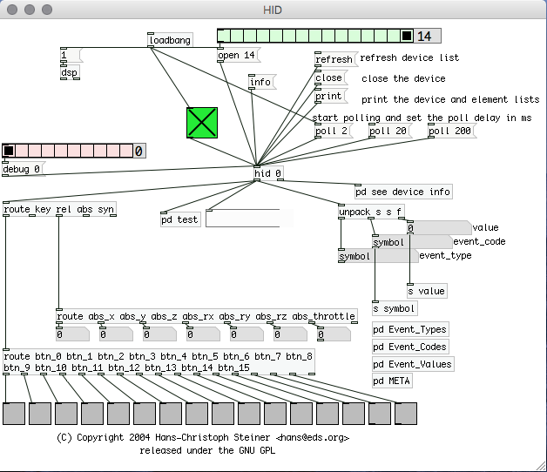
The [HID] subpatch is shown on the right. On my system, the Bluetooth PS4 controller was always device 14, so I made a loadbang that set the HID patch to detect the controller as soon as the patch opened.

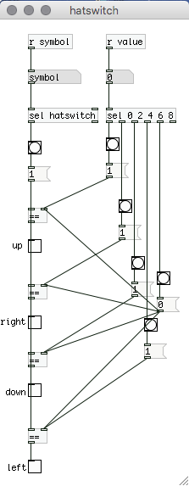
When various buttons on the controller were pressed, the toggles at the bottom of the patch would turn on. However, a problem that I came across was that the UP, DOWN, LEFT, RIGHT buttons on the controller were not set up as button toggles on the HID patch.

I solved this problem by making a subpatch that took the symbol and value of the buttons being pressed and made my own toggles for them. For the mentioned buttons, the symbol would be “hatswitch” and the value would be “0, 2, 4, 6, 8” dependent on which one and whether it was being pressed.

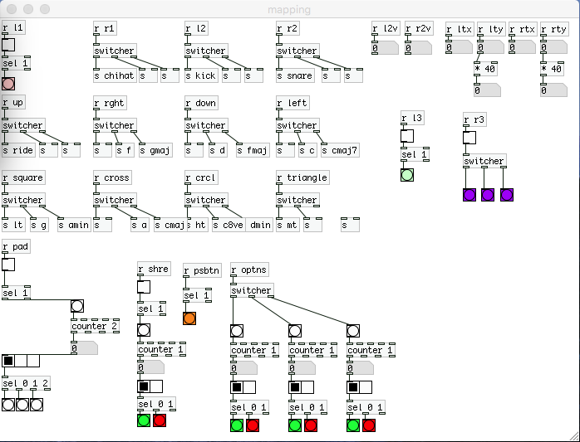
Following the completion of the HID subpatch, I made one for mapping, which took the status of each button (1 or 0) through object receive and sends and sent them to individual samples.

On the right is the final state of the mapping subpatch. I decided that I wanted the centre pad on the controller to switch what instrument I was using.

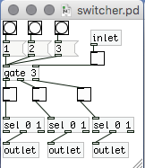
I made an abstraction called switcher.pd which takes the output of the centre pad, and each time it is pressed, it cycles which sample every button sends to on the controller. This is shown on the right.

For example, when the centre pad is on the first step of the horizontal radio object (boxed in blue), the buttons map to the drum samples, when it is on the second step, they map to bass samples, and on the third step they send to chord samples.
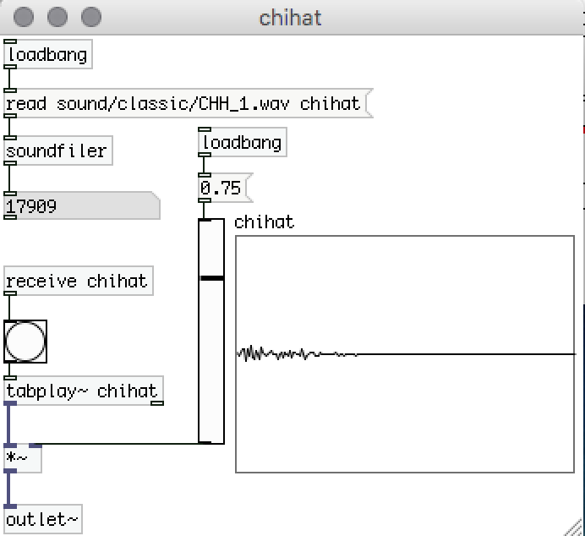
To the left is an example of the sample subpatch I used, it loads the sample from the sound directory in the patch folder as soon as the patch opens, as well as setting the volume level to 75%. On the mapping screenshot above, these are the send objects boxed in red. The object boxed in yellow is the button which triggers these samples.

After mapping all of the samples to the buttons, I decided to make a simple to understand GUI or “graphical user interface” that would open when the patch was opened.
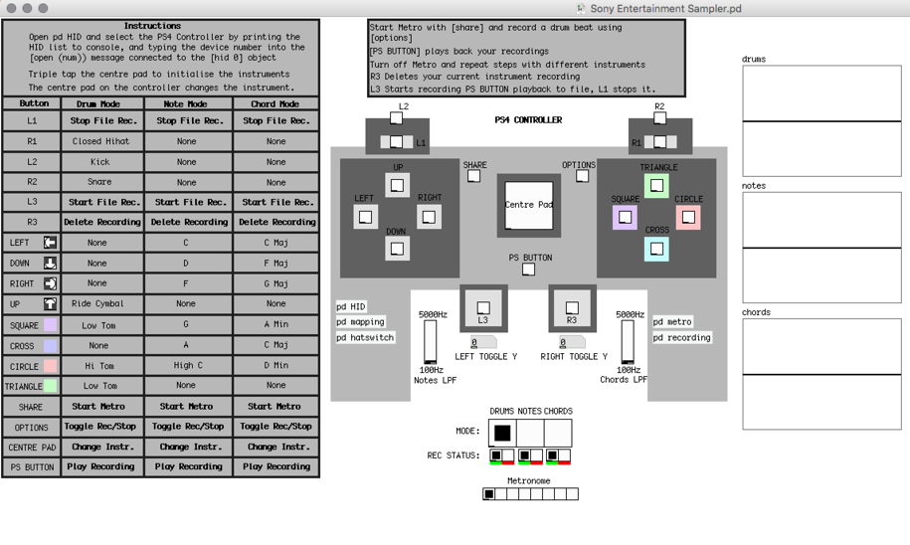
To the right is the GUI I created with different coloured canvas objects in order to depict the controller. I wrote a set of instructions in the top left and centre and a table of all the mappings so that the user does not have to refer to the mapping subpatch.

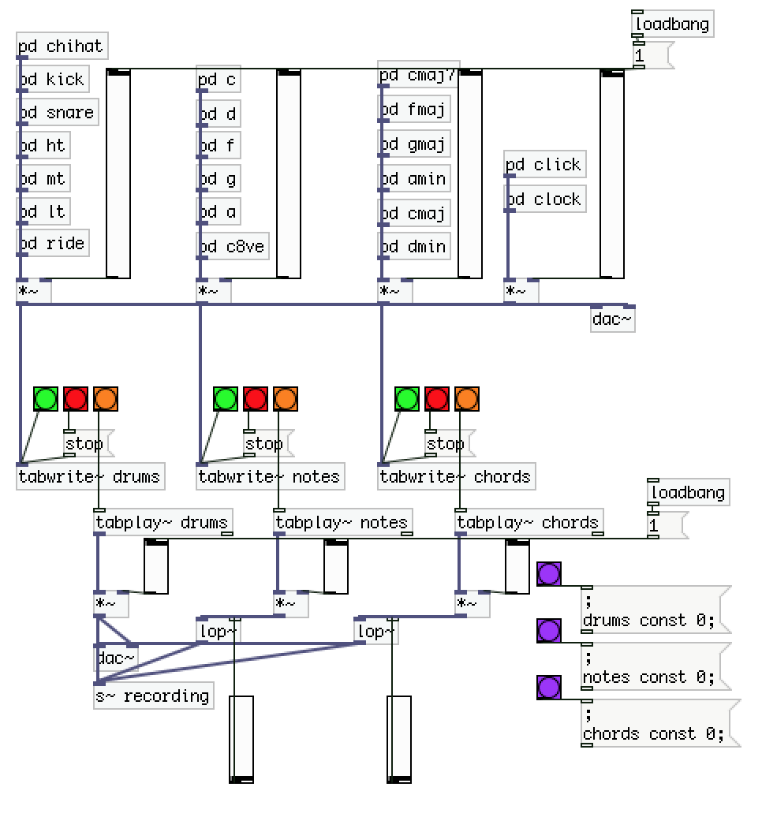
After successfully making a GUI, I decided that the patch lacked functionality due to its inability to record, so in the oscillator section (which that takes the output of the individual sample subpatches), I created [tabrwrite~] and [tabplay~] objects that write the instruments to arrays. The oscillator section is shown to the left.
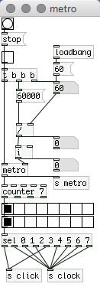
The oscillator section includes a ‘mixer’ of sorts, with [*~] objects taking the output of each instrument and mixing them into the [dac~] with different volume levels.

There are four inputs to the digital to audio converter: the drums, the bass notes, the chords, and the metronome. I created a BPM metronome to allow the
user to to play the drums steadily when
starting a new piece of music (shown on the left).

I mapped the centre “PS” Button to play whatever was stored in the 3 arrays, so that the user can play the bass instrument for example, over their recorded drums and chords. I realized at this point that I was not making use of the toggles on the controller, which send outputs of 0 – 255 on the X and Y axis of both. I decided it would be interesting to making these change the threshold of a lowpass filter on the bass and chords, so I took the output of the Y axis on both, and routed them to two [lop~] objects. The mapping can be seen in the top right corner of the mapping subpatch with the receives from [r rty] and [r lty].

To finish off the patch, I added a “recording” subpatch, which takes the output of the drums and the lowpass filtered bass and chords, and records them in stereo to a file called “Demo1.wav” in the directory via a [writesf~ 2] object. I feel that this adds a lot of functionality to the patch as it allows the user to then use their recording in other musical applications.

To improve this patch in the future, I would like to add the ability to set the array length to be dependent on the BPM of the track. Currently, the array length is set to 705600 samples as it is 8 bars of 60BPM. The user has to change both the BPM and the array length If they want to have a different tempo song as the [tabwrite~] objects stops recording at 705600 samples.

Also the ability to record vocals through a [adc~] object would add more compositional capability to the patch.

Although it is not natively supported by the [HID] object, I would like to be able to route the audio out of the patch to the small speaker in the controller as it would be interesting to have the PS4 as a standalone sampler, adding to this idea, putting the patch onto a small Bluetooth enabled device like a Raspberry PI or Arudino and then mounting it on the controller would make the concept completely computer free.

I feel that my patch allows users to look at composition in a different way. Although the PS4 controller is not intrinsically musical, it is a control device, just as a MIDI keyboard and a drum pad are, and hopefully could inspire someone to become a professional PS4 controller musician!

